MCj04359670000[1]MCj04359670000[1]

St Patrick’s Nursery, Loughguile

Newsletter October 2015

Dear Parents,

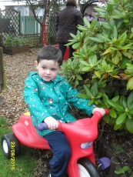

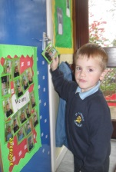Just a note to keep you updated on what has been happening in the nursery. We have been very busy since the start of September. The children (and staff!) have all settled in and are starting to make friends and getting to know each other. All children can come in and register themselves with their photo in the hallway. Now that we are up to our full day we are starting to go outside, weather permitting, and we will be visiting the ‘Big School’ occasionally to use the hall and attend assemblies.

MCj02792520000[1]Our topics for October are Farming and Halloween.



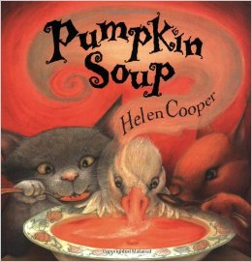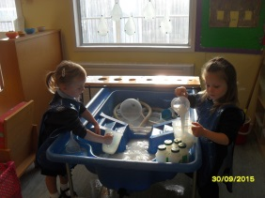Our first topic was farming. For this, I read various stories about farmers and the animals on the farm. In the water tray we had our very own milking parlour. Our water was white and the children had to pour the “milk” through tubes and into milk cartons to be sold in the shops. This encourages the children to use both their fine and gross motor skills, as well as developing their mathematical language associated with capacity.

Coming up to Halloween the children enjoyed the stories of “Room on the Broom” and “Pumpkin Soup”. We loved Room on the Broom and even have the characters from the story flying on the broom around our room.

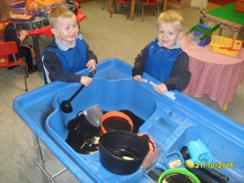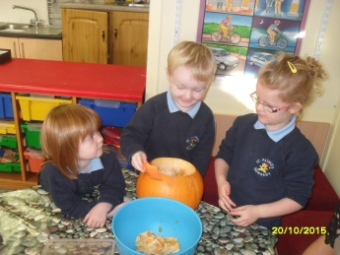We carved pumpkins in nursery and made our own witches potions, adding spiders and other creatures to our black water. We even had glow sticks to make it glow in the dark! We also read stories from the ‘Winnie the Witch’ series which told us about Winnie’s mishaps and adventures. The children thoroughly enjoyed 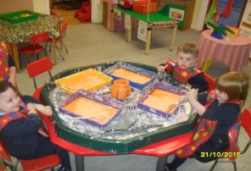dressing up as witches and wizards and casting spells with their wands. They even managed to ‘magically’ change the colour of some jelly from orange to black!! We had a Halloween party and we enjoyed the jelly 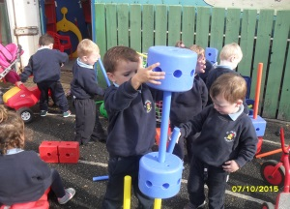with ice-cream.

j0410591We’ve also played with a variety of construction toys, completed jigsaws and painted during activities, etc. I am sure your homes are all becoming decorated with the children’s lovely art work!!

During the month of November we will be beginning our forest animal and autumn theme and then coming into December it will be all about “The baby Jesus” and Christmas. In December we will be inviting you to join us for a Christmas story and some songs to help the children prepare for the big day!!

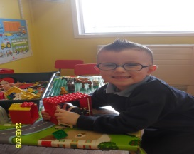

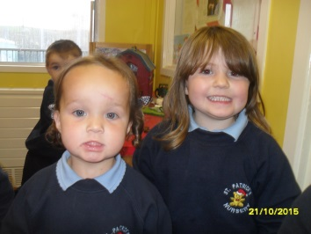*Mrs Donnelly & Orlagh*

October Songs

Old Mac Donald

The Farmer wants a Wife

The Wheels on the Bus

The Rainbow Song

Ring-A-Ring-A-Rosies

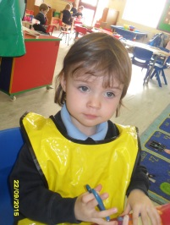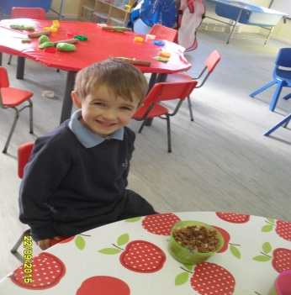

### Nursery Holidays & Exceptional Closures

Mid-term break: 26th October – Friday 30th October (inclusive)

Christmas Holidays: 21st December – Friday 1st January (inclusive)

Mid-term break: 15th February – Friday 19th February (inclusive)