St Patrick’s Primary School and
Nursery Unit
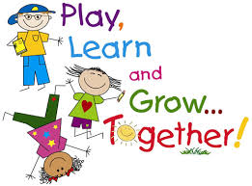
Loughguile

PASTORAL CARE
Policy on photography
in school
(Reviewed and updated 2018)
In St Patrick’s, we promote and celebrate school and individual success and seek to capture significant events, achievements and learning opportunities.
As such, our children may be photographed or recorded in the following school activities
- Curriculum learning
- Special class days
- School activities/events
- Shared education events
- School trips, including residentials
- Achievement awards
- Special events e.g., Christmas play, Sports Day
These may be used for school displays, on the school website or published in local press. Only children’s christian names will be used alongside photographs. We are also sensitive and aware of those children/parents who do not wish to have their photographs taken or displayed and so we request parental/guardian consent in accordance with this policy.
The school cannot be accountable for photographs or videos taken by parents or audience members at school functions but we actively discourage this and appeal for cooperation in this matter.

